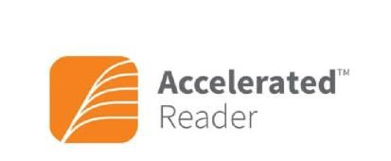

A Parent’s Guide to Accelerated Reader
Little Sutton C of E Primary School

This guide will give you detailed information about Accelerated Reader
(AR). If you have any further questions, please contact your child’s teacher or visit the AR website at www.renlearn.co.uk to find out more.

What is Accelerated Reader?

AR is part of a reading software package recently adopted by the school to encourage and improve reading, measure growth of the individual reader and to provide quality reading for all. It allows for personalised learning targets to be set up and for progress to be easily monitored. This short guide will help you to understand the system better so that you can support your child with their reading.

Your child will choose a book at their own level and read it at their own pace. When finished, they will take a short quiz on an ipad/ computer at the quizzing station set up in each classroom. Passing the quiz is an indication that your child has understood the book.

AR gives both children and teachers feedback based on the quiz results, which the teacher then uses to help your child set goals and direct ongoing reading practice.

AR is used as part of a comprehensive reading programme in place at Little Sutton C of E Primary School. While we continue to teach the skills of reading in class through guided reading, whole class texts and Pathways to Read, the AR books chosen by your child will provide them with the opportunity to apply the knowledge and skills they have developed.
Pupils using AR are encouraged to progress at their own pace and they have personalised targets based on their reading ability. The aim of AR is for all children to succeed in achieving their targets.

What are STAR Reading Tests?

Every child taking part in AR will complete regular STAR reading tests. This a 20-minute multiple choice reading assessment completed individually on the computer. Questions continually adjust to your child’s responses so if their response is correct, the difficulty level is increased. If they miss a question or give an incorrect answer, the difficulty level is reduced.

The STAR reading test, along with teacher judgement assists us in identifying a child’s ZPD (Zone of Proximal Development) range.

For some children in school, taking the STAR reading test may not be appropriate at the moment, therefore some children will continue to have access to books which are suitable to their reading level eg colour banded books.


What is a Zone of Proximal Development (ZPD)?

After your child takes a STAR reading test, the teacher will assess the results and give them a ZPD reading range. The range aims to challenge a child without causing frustration or loss of motivation.

How do I know what books my child can read?

Our school has now scanned and labelled our existing books and we are in process of purchasing new books (fiction and non-fiction). All our books are in new bookshelves in the corridors according to their ZPD number.

Your child will know their range (it will be written into their reading records) and the books they should be choosing. A ZPD can change throughout the year based on STAR reading tests, professional judgement and quiz results.

Your child’s class teacher has details of your child’s username and password to access the quizzes at school and their ZPD range.

Each book in school has an individual label on the inside cover which shows important information. This is an example of a book label.
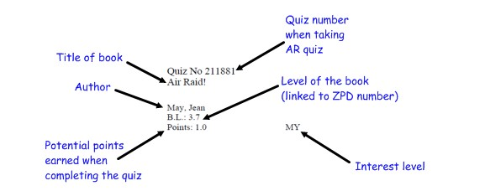

B.L. = book level. A child uses their ZPD range to decide which books are appropriate for them to read. A child with a ZPD range of 2.8 – 4.0 would be able to read ‘Air Raid’ (example label) and it will be slightly challenging for them as it is towards the top end of their ZPD range.

Points = points value based on the difficulty of the book and the number of words.

LY/MY/UY = Lower Years, Middle years, Upper Years interest level

Lower Years – books for children aged 5 – 8 years old (KS1)
Middle Years – books for children aged 9 – 13 years old (KS2&3)
Middle Years+ - books for children aged 12-13 (KS2)
Upper Years – books for children aged 14 and above (KS4)

Just because your child can read the words in a book does not mean the content is appropriate. The interest level of the material must be considered also.

What are the AR Quizzes?

When your child has finished reading a book they will be given time to take a quiz independently on ipads/ computers in school. We aim for all quizzes to be taken within 48 hours of finishing a book.

There are two main types of quizzes your child will take:

- Reading Practice Quizzes. These are the most common type of assessment. The purpose is to determine whether your child has read a book, measure your child’s literal comprehension of the book and provide immediate feedback. Each quiz consists of 3, 5, 10 or 20 multiple-choice questions depending on the book level and length.

- Vocabulary Practice Quizzes. These measure a child’s understanding of vocabulary words encountered while reading. They are designed to reinforce vocabulary acquisition, assist with individualising vocabulary instruction and generate your child’s interest in words through authentic, in-context literature experiences. Quizzes include 5, 10 or 15 words from a particular book as well as review words from previously read books.

Depending on the book level the quiz will take around 5-10 minutes to complete. The results are calculated and shown to the child instantly.

Children earn points, or a portion of the book’s points, depending on how well they do on the Reading Practice quiz. For example, a child who takes a 5-question quiz on a book worth 1 point will earn 1 point for 5 correct answers (100%), 0.8 point for 4 correct answers (80%) etc. A child who reads a book worth 5 points and takes a 10-question quiz will earn the full 5 points for 10 correct answers (100%), 4.5 points for 9 correct answers (90%) etc. For quizzes with 3, 5 or 10 questions, a child needs to pass a quiz with a score of 60% or higher to earn points. For quizzes with 20 questions, a child needs to pass with a score of 70% or higher to earn points.

If your child does not do well on a quiz, they will be encouraged to choose a book that is more appropriate. You can help by asking questions about the book as your child reads it at home.

The number of quizzes continues to grow as new books are added to AR. Your child can take a quiz when:

- they have read a book independently;
- a teacher has read a book to them, e.g. class novel; • they have read a book with someone, e.g. parent, teaching assistant.

Your child can bring in books from home or the local library to read as part of AR if their teacher feels they are suitable. To conduct a simple book search to see if a book is on Accelerated Reader go to www.arbookfind.co.uk



How will I know how my child is doing?

Home Connect is a website that links school and home to keep parents informed of their child’s progress in AR.

https://global-zone61.renaissance-go.com/welcomeportal/6708390

Simply enter your child’s user name and password (all children have been given their details) and you will be able to:

- review results on AR quizzes taken in school
- view the number of books read, words read and quizzes passed
- see a virtual bookshelf showing the books your child has read
- sign up (optional) to receive an email every time your child takes a quiz to share the results with you instantly

What see when you log into Home Connect

Type of quiz Child’s last quiz results
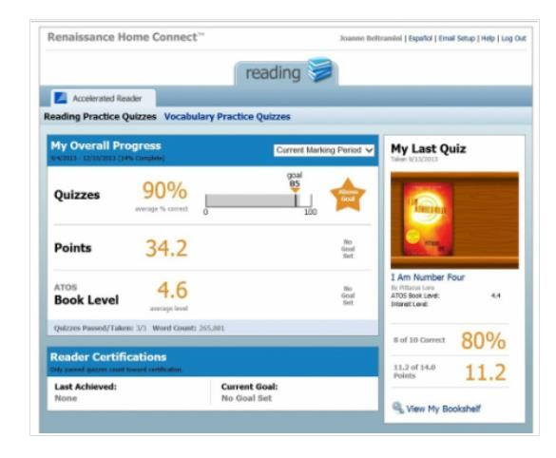

Overall progress so far showing average % of correct quiz answers, points collected so far and average book level read.

My Bookshelf
On Home Connect, parents and children can see all the books the student has read.
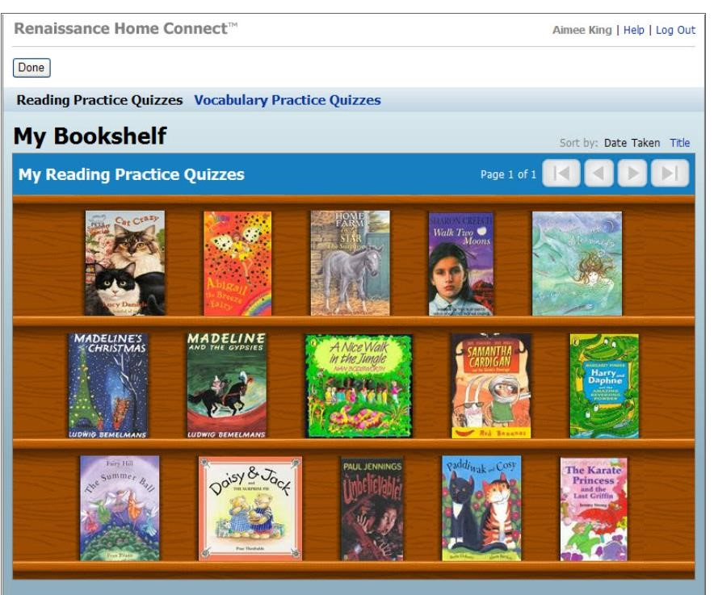
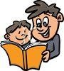
Clicking a book shows details about it, such as book level, word count and points.
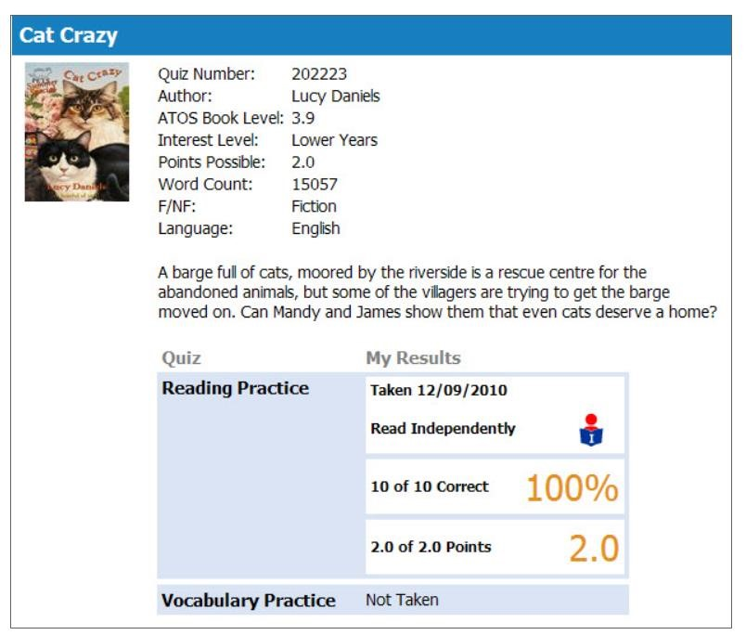

How can I help?

As with anything, performance improves with practice. We provide lots of opportunities for reading in school but you can help by encouraging reading at home too.

Logging on to Home Connect with your child at home is a great way to discuss the books they have read and their overall progress in reading. Encourage your child to read with you and/or discuss what they have read. A child may be able to decode and read the words but may not have understood it, so asking questions about the book is important. Reading with your child, no matter what the age, is an important part of developing good reading skills and a lifelong love of reading.


Expectations for reading at home:

• At Little Sutton C of E Primary school, our aim is that children will read at home between 5 times a week.

Year 6
- Children read to an adult or independently 5 times a week- please try and hear them at some points or ask them questions about what they have read
- Children can sign their own reading diary with a comment about the book

I appreciate that this leaflet has a lot of information in it!

The key points are:

- The expectations for reading at home
- How to log into home connect to see what your child had read and how they are doing
- Use the links from the leaflet to log on as it needs to be the specific host. It can be copied/ typed into your browser.
Accelerated Reader Link

https://ukhosted128.renlearn.co.uk/6703602/HomeConnect/Login.aspx

- Please make sure your child has their reading diary and book in their school bag every day.

Thank you for your support,
Mr Walker

