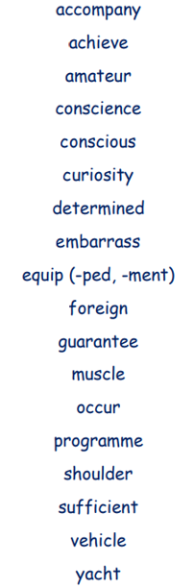
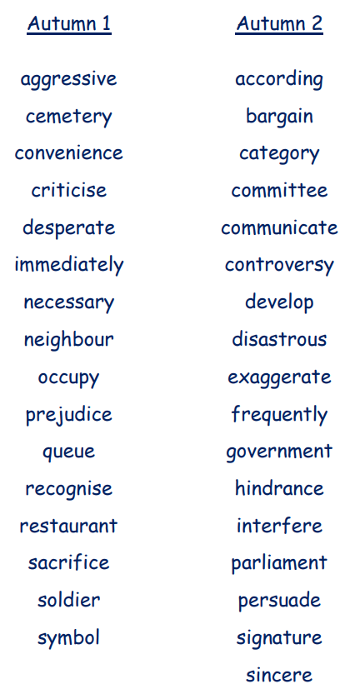
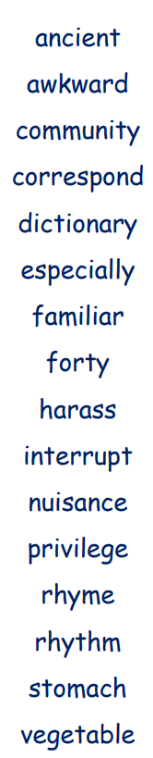
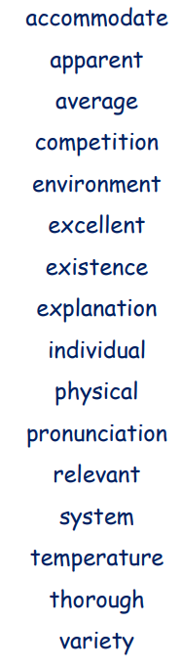

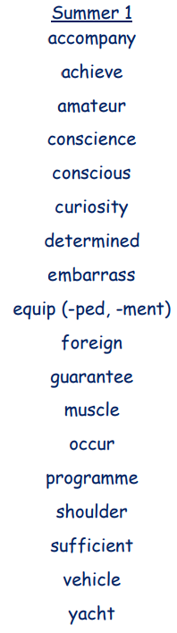
Spring 1 Spring 2 Summer 2

